## Math 120

## Test 4B

Student Name: _______________________________________ Student Number: ______________________

Directions:

* SHOW ALL YOUR WORK OR JUSTIFICATION FOR ANSWERS *ON THE TEST*. Scrap paper is sometimes hard to read and I want to give you partial credit!
* Simplify all answers.
* Round answers as indicated.
* Include units with final answers.



1. Select values for the exponential function $f\left(x\right)=0.5(4^{x})$ are given in the table that follows. Use the values from this table to complete the table for its inverse $g\left(x\right)=\log_{4}{(2x)}$. (3 points)

| $$x$$ | -3 | -2 | -1 | 0 | 1 | 2 | 3 |
| --- | --- | --- | --- | --- | --- | --- | --- |
| $$f\left(x\right)$$ | 1/128 | 1/32 | 1/8 | ½ | 2 | 8 | 32 |

|  | 1/128 | 1/32 | 1/8 | ½ | 2 | 8 | 32 |
| --- | --- | --- | --- | --- | --- | --- | --- |
| $$g\left(x\right)$$ |  |  |  |  |  |  |  |

Fill in this empty row with values ^

2. Use the function $f(x)={\left(\frac{1}{3}\right)}^{x}$

1. Fill in the table with integers or fractions (3 points)

| $$x$$ | -3 | -2 | -1 | 0 | 1 | 2 | 3 |
| --- | --- | --- | --- | --- | --- | --- | --- |
| $$f\left(x\right)$$ |  |  |  |  |  |  |  |

b. Use the table above to graph. (2 points)

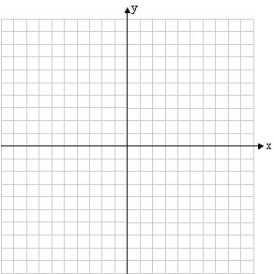

C. State the domain of your graph in interval notation. (1 point) __________________

d. State the range of your graph in interval notation. (1 point) __________________

3. Match the information to the graph. Write in A, B, C, or D in the blanks. (4 points)

A 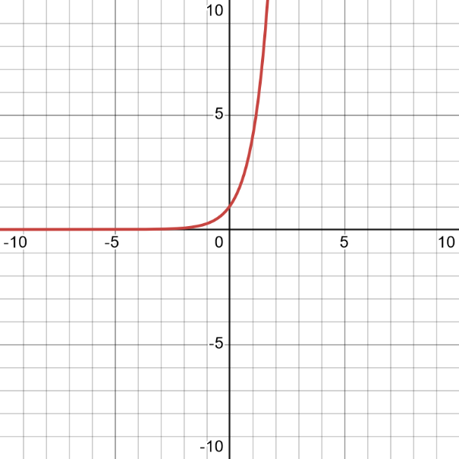 B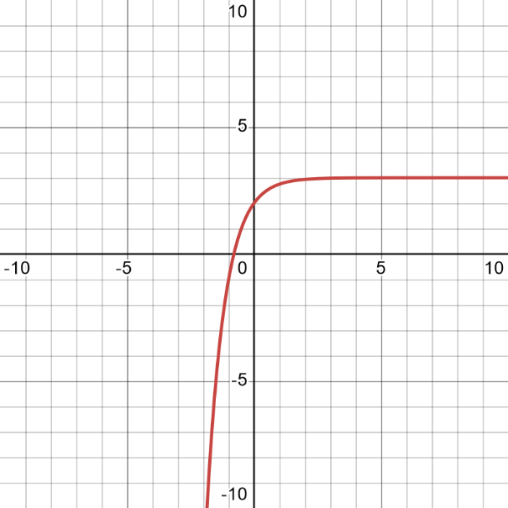

C 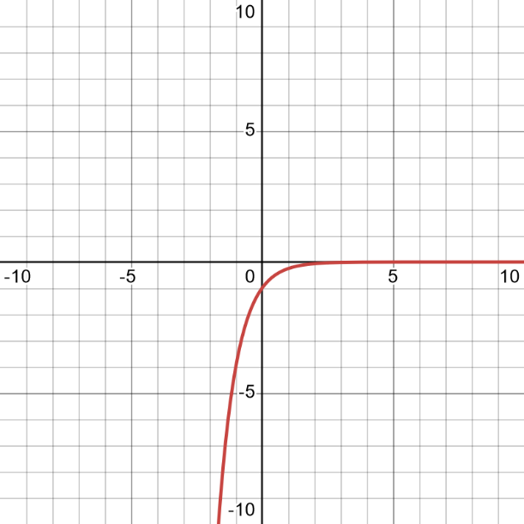 D 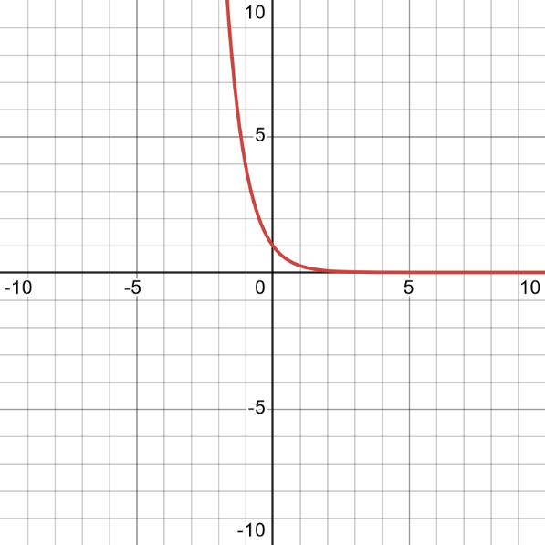

_____________________ _____________________

_____________________ _____________________

4. Suppose you have $5000 to invest.

a. How much will you yield with 5.5% interest compounded semiannually for 5 years? Include units. (2 points)

a.____________________________

b. How much will you yield with 5.25% interest compounded continuously for 5 years? Include units (2 points)

b.____________________________

c. Which investment yielded a greater return? Circle one. (1 point) COMPOUND or CONTINUOUS

5. Rewrite each equation in it equivalent exponential form. (4 points)

a.  b. 

a.__________________________ b.___________________________

6. Rewrite each equation in it equivalent logarithmic form. (4 points)

a.  b. 

a.__________________________ b.____________________________

7. Evaluate or simplify each expression without using a calculator. (4 points)

a.  b. 

a.__________________________ b.____________________________

8. Students in a psychology class took a final examination. As part of an experiment to see how much of the course content they remembered over time, they took equivalent forms of the exam in monthly intervals thereafter. The average score, *f(t)*, for the group after *t* months is modeled by the function  where 0 ≤ *t* ≤ 12.

a. What was the average score when the exam was first given? In a complete sentence, explain your answer in the context of the problem. (2 points)

__________________________________________________________________________________________

__________________________________________________________________________________________

__________________________________________________________________________________________

b. What was the average score after 8 months? Round to the nearest tenth. (2 points)

_____________________________

c. After how many months will the average score be 60? Round to the nearest tenth of a month. In a complete sentence, explain your answer in the context of the problem. (2 points)

__________________________________________________________________________________________

__________________________________________________________________________________________

__________________________________________________________________________________________

9. Use the properties of logarithms to expand the expression as much as possible. Where possible, evaluate logarithmic expressions without using a calculator. (4 points)



______________________________________________________

10. Use the properties of logarithms to expand the expression as much as possible. Where possible, evaluate logarithmic expressions without using a calculator. (4 points)



______________________________________________________

11. Use the properties of logarithms to condense the expression as much as possible. Where possible, evaluate logarithmic expressions without using a calculator. (4 points)



____________________________________

12. Use the properties of logarithms to condense the expression as much as possible. Where possible, evaluate logarithmic expressions without using a calculator. (4 points)



____________________________________

13. Penicillin has a half-life of approximately 1.4 hours. The function represents the amount of penicillin, *P(t)*, left in the bloodstream after *t* hours. Suppose you take 300 mg of penicillin.

a. How much penicillin will be left in the body after 5 hours? Round to the nearest tenth. (2 points)

a.___________________________

b. How much penicillin will be left in the body after 10 hours? Round to the nearest tenth. (2 points)

b.___________________________

c. How much penicillin will be left in the body after 20 hours? Round to the nearest hundredth. (2 points)

c.___________________________

d. Looking at the mathematical model presented above, will the Penicillin ever leave the body according to your answers above?  Circle your answer. (1 point)

YES or NO

e. While the mathematics tells us one thing, this is actually a real-life situation.  In reality, will the Penicillin ever leave the body?  Circle your answer. (1 point)

YES or NO

14. Solve the exponential equation. Round to the nearest tenth if necessary. (4 points)



___________________________

15. Solve the exponential equation. Round to the nearest tenth if necessary. (4 points)



___________________________

16. Use the following logarithmic equation.



a. Find the domain of the original equation. Answer in interval notation or set notation. (2 points)

a. _________________________

b. Solve the logarithmic equation. (4 points)

b. ________________________

17. Use the following logarithmic equation.



a. Find the domain of the original equation. Answer in interval notation or set notation. (2 points)

a. ________________________

b. Solve the logarithmic equation. (4 points)

b. ________________________

18. In 2000, the popular social media platform 'FriendLink' had 35.3 million registered users in the United States. By 2010, the user base had surged to 50.5 million. Let *A* represent the number of FriendLink users in millions, and *t* be the years after 2000. Suppose the growth of FriendLink users in the United States follows an exponential growth model: 

a. Find the relative rate of change *k*. Round to 3 decimal places. (2 points)

a.________________

b. Using your previous *rounded* answer, find the exponential growth model that describes the population $t$ years after $2000$. (1 point)

b.________________________________

c. Use the resulting model to project the number of FriendLink users in 2015. Round to the nearest user. (2 points)

c.________________

d. In which year will the number of FriendLink users reach 70 million? Round to the nearest year. (2 points)

d.________________

19. In a certain region, an ancient tree species called the Redwood is known for its longevity. Suppose a Redwood tree falls and becomes fossilized. Let *A(t)* represent the amount of Carbon-14 remaining in the fossilized Redwood tree after *t* years since its death, following the exponential decay model:



a. How many grams of Carbon-14 were in the tree when it originally died? (1 points)

a.________________

b. If a scientist discovers a fossilized Redwood tree and measures that it contains only 245 grams of Carbon-14, determine the approximate age of the fossilized tree. Round to the nearest year. (3 points)

b.________________

20. In a bustling city known for its food scene, a new trendy restaurant opens its doors. Imagine a new sushi restaurant has just opened, and excitement is spreading quickly. The number of people a day, *P(t),* who have visited the restaurant *t* days after its grand opening is modeled by the logistic growth function: 

a. How many people initially were in the restaurant? Round to the nearest person. (2 points)

a.________________

b. How many people will go to the new restaurant at day 20 after opening? Round to the nearest person. (2 points)

b.________________

c. In how many days will 200 people a day visit the restaurant? Round to the nearest day. (2 points)

c. **________________**

d. Eventually, how many people a day will visit the restaurant? Explain your answer in the context of the problem using mathematical terms. (2 points)

__________________________________________________________________________________________

__________________________________________________________________________________________

__________________________________________________________________________________________

__________________________________________________________________________________________

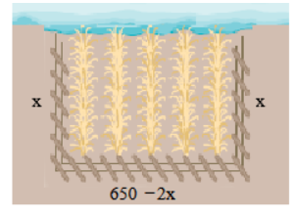

**OPTIONAL EXTRA CREDIT:**

A person has 650 feet of fencing to enclose a rectangular area of land. One side of the land borders a river and no fencing.

a) Find a quadratic model that describes the area of land that the fencing encloses.

c) What is the length that will maximize this area?

b) What is the maximum area?

d) What is the width that will maximize this area?

**Formula Sheet: Math 120**

**Straight Line**

**Slope Intercept form Point-slope form Slope**

  

**Difference Quotient Quadratic Formula**

 

**Logarithms**

  

**Distance**:  **Midpoint**: 

**Circle**: 

**Quadratic Function**

, Vertex =  , Vertex = 

**Compound Interest**:  **Continuous Compound Interest:** 

**Arithmetic Sequence Geometric Sequence**

 Finite:  

 Infinite: , 

**Even function Odd function**

 